DIY Flashlight

Description:
The DIY Flashlight project demonstrates the basic working of an electric circuit using simple components such as a cell, LED, and copper tape.
In this project, a flashlight is made by mounting an LED inside a flashlight cutout and completing the circuit using copper tape as conducting paths.
This project helps beginners understand basic electrical concepts such as current flow, polarity, and circuit completion.
Block Diagram:
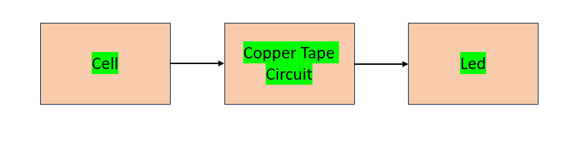

Pinout / Circuit Connection:
Positive terminal of the battery → Copper tape strip → LED Anode (+)
LED Cathode (–) → Copper tape strip → Negative terminal of the battery

Components Required:
1 x Battery Cell (1.5V or 3V coin cell)
1 x LED
Copper Tape
Flashlight Cutout / Cardboard Holder
Insulating tape
Scissors

Working Principle:
The DIY flashlight works on the principle of a closed electrical circuit.
When the battery terminals are connected to the LED through copper tape, electric current flows through the LED.
The LED converts electrical energy into light energy.
Copper tape acts as a conductor, allowing current to flow with minimal resistance.

Operation (Step-by-Step):
- Fix the LED inside the flashlight cutout.
- Paste copper tape to form conductive paths for the positive and negative terminals.
- Place the battery cell in the holder such that it touches the copper tape strips.
- Ensure the LED polarity is correctly connected.
- When the circuit is completed, the LED glows, acting as a flashlight.
- Breaking the circuit (by removing the battery or disconnecting tape) turns OFF the LED.

Conclusion: (Predefined/self-written)
The DIY Flashlight project is a simple and effective way to understand basic electronics and circuit connections.
It demonstrates how electrical energy from a battery can be converted into light energy using an LED.
This project is ideal for beginners and school-level demonstrations.

